**Effect of D-Alpha Tocopherol Therapy towards Malondialdehyde Level and Histology of Kidney in Rattus norvegicus with MLD-STZ Induction**

Marissa Agnestiansyah1*, Aulanni’am1, Chanif Mahdi1

1Department of Chemistry, Faculty of Science, Brawijaya University, Jl. Veteran, Malang 65145, East Java Indonesia

*Email: ichaansya@gmail.com

**ABSTRACT**

*Diabetic Nephropathy is a kidney disease which occurs due to complication of diabetes mellitus as a consequence of the damage of the kidney endothelial cells. Hyperglicemia condition in patients with diabetes mellitus that induces an oxidative stress, were related to endothelial cell damage. Oxidative stress as a result of hyperglycemia will activate a number of signal transduction pathways resulting in increase of free radicals. D-alpha tocopherol as one of antioxidant substance, that can act as an inhibitor of free radical chain reactions, play an important role in the reduction of the oxidative stress effect. Effect of D-alpha-tocopherol in reducing oxidative stress is identified by the levels of malondialdehyde (MDA) in kidney and histology of kidney. This study used five groups mice; they were a control group, a diabetic group which was induced with MLD-STZ, and a therapeutic groups with a varieties doses of D-alpha tocopherol (100 mg/kgBW, 200 mg/kgBW and 300 mg/kgBW). The results showed that the D-alpha tocopherol was able to reduce the levels of malondialdehyde (MDA) and repair the histology of kidney of mice induced by MLD-STZ.*

**Keywords:** Diabetic Nephropathy, Diabetes mellitus, MLD-STZ, Malondialdehyde, D-Alpha tocopherol

Corresponding author : ichaansya@gmail.com

Phone : +62341575838

Mobile : +6281339640029

1. **INTRODUCTION**

Complications of diabetes in the kidney is known as diabetic nephropathy. Based on Microalbuminuria Prevalence Study (MAPS), nearly 60% of patients with hypertension and diabetes in Asia had diabetic nephropathy. The percentage is made up of 18.8% macroalbuminuria and 39.8% microalbuminuria (American Diabetes Association, 2004). Damage to the kidneys filter or glomerolus occurs in patients with diabetic nephropathy. Glomerolus damage will cause some blood proteins excreted abnormally in urine. This situation is called as glomerolus hyperflitration (Pardede, 2008).

Glomerular hyperfiltration is due to endothelial kidneys cell damage. One of the causes of endothelial cell damage is oxidative stress that occurs in people with diabetes because of hyperglycemia (Yulianti, 2009). Hyperglycemia stimulates the release of superoxide in mitochondria, triggering early oxidative stress in patients with DM. Source of oxidative stress in diabetic patients proceed against non-enzimatic pathway, enzymatic and mitochondrial pathways. Enzymatic sources of oxidative stress is derived from the enzymatic glucose. Glucose can undergo autooxidation and generate OH radicals. In addition, glucose reacts with non-enzymatic proteins that produce Amadori products followed by the formation of Advanced Glycation End Products (AGEs) which increase the oxidative stress. Polyol pathway in hyperglycemia also produces the radical •O2-. Autooxidation process on hyperglycemia and glycation reactions will trigger the formation of free radicals, particularly Superoxide (•O2-) and Hydrogen peroxide (H2O2), then the Haber-Weis and Fenton reactions will convert the previous radicals into hydroxyl radicals (OH-). Hydroxyl radicals attack Poly Unsaturated Fatty Acids (PUFAs) in cell membranes, resulting in the formation of hydroperoxide lipids and MDA. The latter compound will cause oxidative damage to kidney cells (Wiyono, 2003).

The damage of oxidative stress in people with diabetes mellitus can be resisted by a diet of high levels antioxidant food. One of antioxidant that serves to reduce oxidative damage in diabetics is vitamin E. According to Aggarwal (2011), vitamin E has been shown to reduce microalbuminuria and repair kidney damage in patients with diabetic nephropathy. The majority of natural supplements of vitamin E are in the form of D-alpha tocopherol. D-alpha tocopherol can work as a scavenger of oxygen free radicals, lipid peroxyl and singlet oxygen. D-alpha tocopherol is also known as an antioxidant that can maintain the integrity of the cell membrane (Maulana, 2010).

To the best of our knowledge, the use of D-alpha-tocopherol in reducing oxidative stress in diabetic nephropathy has not been studied. Therefore, in this study, we observe MDA levels and histology of kidney tissue in the diabetes mellitus type 1 mice that are treated with D-alpha tocopherol.

1. **MATERIALS AND METHODS**

**Animals and experimental design**

Twenty-five Rattus norvegicus (male, body weight 130-160g) were housed at room temperature in the animal house of Cellular and Molecular Biology Laboratory, Mathematics and Sciences Faculty, Brawijaya University Malang and were exposed to alternate cycles of 12 h light and darkness. The mice were divided into five groups as follows : control (non-diabetic) group (n = 5), diabetic group (n = 5) which is induced by multiple low dose-streptozotocin (MLD-STZ) for five days and incubated for fourteen days until their glucose blood level was more than 300mg/dl. STZ dose used was 20 mg/kg BW for five consecutive days (Lukiati, 2012). Therapeutic groups are treated with variant doses of D-alpha-tocopherol (100; 200, and 300 mg/kg BW) after induced by MLD-STZ. Each D-alpha-tocopherol dose group contained 5 mice. At the end of the experiment, kidneys were collected by cervical dislocation. The kidneys were washed with 0.9% NaCl and the left kidneys were immersed in PBS for five minutes. The right kidneys were immersed in 4% PFA for seven days for further kidney tissues observation. All conditions and handling animals were conducted with protocols approved by Ethical Clearences Committe of Brawijaya University (No. 121-KEP-UB).

**MDA Measurement using Thiobarbituric acid (TBA) Test**

1.8 grams of kidney were homogenized 1 mL of NaCl 0.9% in a cold condition by using a block ice for conditioning. The homogenate was centrifuged at a speed of 8000 rpm for 20 minutes and supernatant was taken. Then 100 μL of kidney supernatant was added by 550 μL aquadest, 100 μL TCA 100%, 250 μL HCl 1 N, and 100 μL Na-Thio. At each reagent addition was homogenized with a vortex. The mixture was centrifuged at 500 rpm for 10 minutes and supernatant was taken. Furthermore, the solution was incubated in the water bath at 100° C for 30 minutes and left until it reach room temperature. The samples were measured at 541 nm for TBA test.

**Histological analysis of kidney tissues**

Kidneys were fixed in paraformaldehyde solution and were dehydrated with a gradual ethanol series, then were embedded in paraffin to bring out an ultrathin sections of kidneys. Furthermore, the ultrathin sections were stained with Hematoxylen-Eosin. First, the ultrathin sections were deparaffinized with xylol and rehydrated with a gradual ethanol series (absolute, 95, 90, 80 and 70%) respectively for 5 minutes. Then those were soaked in aquadest for 5 minutes. Furthermore, the ultrathin sections were dyed with hematoxylen and were incubated for 10 minutes to obtain the best color results. Then the ultrathin sections were washed with flowing water for 30 minutes and rinsed with aquadest. Next, the ultrathin sections were dyed with eosin with alcohol for 5 minutes. The last step were dehydrated using a gradual series of ethanol (80%, 90%, 95%, and absolute) and cleared with xylol then dried. The dried and stained ultrathin sections were mounted with entellan and were observed under a microscope (Olympus BX53) with a magnification of 600 times.

1. **RESULT AND DISCUSSION**

**Therapeutic Effect of D-alpha tocopherol Against MDA Levels of White Rat Kidney Induced MLD-STZ**

A number of diabetic nephropathy pathogenesis pathway cause of hyperglycemia increases the amount of free radicals in the body. The imbalanced condition between free radicals and cellular antioxidants in the body will induce an oxidative stress and related to oxidative damage.

One of these pathogenesis pathway was sorbitol polyol pathway. Sorbitol polyol pathway activation reduces the number of reduced Nicotinamide adenin dinucleotida phosphate (NADPH) which is required to convert Glutathione disulfide (GSSG) into Glutathione (GSH). GSH is an important cellular antioxidant and GSH reduction will lead to oxidative stress. Autooxidation glucose that occurs due to hyperglycemia is also a source of hydrogen peroxide (H2O2) and superoxide (•O2-). Hydrogen peroxide and superoxide via the Habber-Weis reaction include Fenton reaction step will be converted into hidroxyl radicals (Setiawan and Suhartono, 2005).

Lipid peroxidation is one cause of oxidative damage which involves the reaction between hydroxyl radical with Poly Unsaturated Fatty Acids (PUFA) (Valko, 2006). Lipid peroxidation which happens in the cell membrane of the kidney will cause a kidney disfunctioned and it will leading to the end-stage condition that called kidney or renal failure. Levels of oxidative damage caused by lipid peroxidation can be checked through the measurement of MDA (Chang, et al., 2005).

Unsaturated double bonds in PUFA facilitates hydroxyl radical attack on the acyl chain. PUFA becomes radical lipid through the taking of one hydrogen atom from one methylene group. Lipid radicals react with oxygen in the body forming lipid peroxyl radicals. Peroxyl lipid radicals attack the other lipids so that it generates lipid peroxide and new lipid radicals. This reaction occurs continuously forming a chain reaction. Lipids peroxyl radical have an rearrangement through cyclisation reaction to form MDA (Valko, 2006). Lipid hydroperoxide is an unstable compound and its fragmentation will produce a product such as MDA (Gotto, et al., 2009).

MDA levels of kidney tissue was measured by TBA test. TBA test principle is a condensation reaction between one molecule of MDA with two molecules of TBA in acid condition as displayed in **Fig. 1.** Complex of MDA and TBA produced a pink color that can be measured at a maximum wavelength of 541 nm. MDA levels indicates the number of lipid peroxidation and cell damage that occured. The higher levels of MDA was indicate the more severe cell damage that occurs.

As shown in **Table 1,** the levels of MDA in diabetic mice were significantly higher compared with non-diabetic mice. Therapy with D-alpha tocopherol may reduce elevated levels of MDA. MDA levels declined with increasing doses of D-Alpha tocopherol used.

Statistical test results showed that there were significant differences (P<0,01) between MDA levels of diabetic mice and therapeutic mice. It suggests that the D-alpha tocopherol able to act as an antioxidant especially as a hydroxyl radical scavenger. The decline in MDA levels related to the decreasing of lipid peroxidation in cell membranes that leads to the reducing of cell membrane damage and inhibition of diabetes mellitus complications.

Landes (2005) studied that the inhibition mechanism of lipid peroxidation by D-alpha tocopherol which initiated when lipids (LH) lost an atom hydrogen became lipid radical (L•). Lipid radicals will react with molecular oxygen to produce lipid peroxyl radical (LOO•). Lipid peroxyl radicals can react with other unsaturated lipids and caused a chain radical reactions. At this stage, D-alpha tocopherol will donate one H atom from its hydroxyl (OH) group to lipid peroxyl radical. In the rest, those D-alpha tocopherol become non active alpha tocopherol radical and can be excreted out of the body.

**Histology of Kidney Tissue from Control Mice, Diabetic Mice, and The Therapeutic Mice**

Free radicals are the result of normal product of cell metabolism. However, some circumstances may interfere the balance between ROS production and cellular defense mechanisms that lead to cell disfunction and cell damage. Fibrosis and endothelial cell damage due to oxidative stress could cause damage to kidney tissue and kidney disfunction. The histology of kidney tissues were obrserved to determine both the level of damage and organ repair.

Comparison of kidney kosistensi tissue damage between the control mice, diabetic mice and therapeutic mice can be seen in the results of Haematoxylen Eosin staining results as displayed in **Fig. 2**. Glomerolus cells and tissues in control mice kidney looks intact and compact. The boundaries between one cell and another in control mice kidney tissue are clearly visible. The boundary between one cell and another in diabetic mice can not be seen. Glomerolus cells of the diabetic mice looks not intact. It indicates that MLD-STZ induction has been damage the endothelial cells of diabetic rats kidney.

After receiving therapy of D-alpha tocopherol, glomerolus looked better and the boundaries between the cells became clearly visible. The higher dose of D-alpha tocopherol therapeutic bring out a better repair of histology of kidney tissues and the therapeutic dose of D-alpha tocopherol 300 mg/kgBW in diabetic mice can restore kidney tissue structure almost like normal mice kidney. D-alpha tocopherol really can maintain the integrity of cell membranes by inhibited lipid peroxidation reaction.

**IV. CONCLUSION**

D-alpha tocopherol therapy with varieties of doses (100; 200 and 300 mg/kgBW) in diabetes mellitus rats which is induced by MLD-STZ showed a decreasing of MDA levels, respectively for 71.63%, 75.51%, 77.27%. D-alpha tocopherol therapy also showed a repair of histology of kidney tissues in accordance with the increasing dose given.

1. **ACKNOWLEDGEMENT**

This study is part of into the development research of Herbal Therapy for DM Diseases. The author would like to thank Dr. Ora Et Labora Immanuel Palandeng, SpTHT-KL as members of research team Herbal Therapies Development for DM Diseases. The authors thank Dr. Sasangka Prasetyawan, MS and Dra. Anna Roosdiana, M.App.Sc. for the discussion and Dr. Sc Akhmad Sabarudin who helped the forming of this manuscript.

1. **BIBLIOGRAPHY**

Aggarwal, H.K., D. Jain, S. Sindhu, and R. Yadaf, 2011, *Evaluation of Role of Low Molecular Weight Heparin and Vitamin E on Renal Finctions in Patients With Diabetic Nephropathy*, Dicle Medical Journal, Vol. 38(2):129-133

American Diabetes Association, 1994, *Standards of medical care for patients and its Complications*, World Health Organization Department of Noncommunicable Disease Surveillance, Geneva.

Chang, J.M., C.M Kuo, Y.W. Chiu, H.C. Chen, 2005, *Increased Glomerular and Extracellular Malondialdehyde Levels in Patients and Rats with Diabetic Nephropathy*, The Journal of Laboratory and Clinical Medicine Vol. 146(4):210-215.

Gotto, D., L.S.Maria, J.Valentini, C. Paniz, G.Schmitt, S.C Garcia, V.J. Pomblum, J.B.T. Rocha and M.Farina, 2009, Importance of the Lipid Peroxidation Biomarkers and Methodological Aspects for Malondialdehyde Quantification. *Quim. Nova,* Vol. 32(1): 169-174.

Landes, V.N., 2005, Vitamin E Elucidation of The Mechanism of Side Chain Degradation and Gene Regulatory Functions, Fakultat Mathematisch-Naturwissenschaftlichen, Postdam.

Lukiati, B., Aulanni’am and W. Darmanto, 2012, *The Effects of Curcuma heynena Ethanolic Extract on the Superoxide Dismutase Activity and Histological Pancreas of Type 1 Diabetes Mellitus Rats*, International Journal of Basic and Applied Sciences IJBAS-IJENS Vol. 12(02):22-30.

Maulana, A.I., 2010, *The* *Influence of Mungbean (Phaseolus radiatus) Sprouts Extract to Renal Cell Damaging of Mice (Mus musculus) that be Induced by Paracetamol,* Script, Faculty of Medicine, Sebelas Maret University, Surakarta (In Indonesian)

Pardede, S.O., 2008, *Nefropati Diabetik pada Anak*, Sari Pediatri Vol. 10(1):8-17. (In Indonesian)

Setiawan, B. and E. Suhartono, 2005, *Oxidative Stress and The Roles of Antioxidant in Diabetes Mellitus*, Majalah Kedokteran Indonesia Vol. 55(2):86-91. (In Indonesian)

Valko, M., C.J. Rhodes, J. Moncol, M. Izakovic, M. Mazur, 2006, Free Radicals, Metal and Antioxidants in Oxidative Stress-Induced Cancer, Chemico-Biological Interactions, Vol.160:1-40.

Wiyono, P., 2003, *The Role of Hyperglycemia in the Development of Chronic Complication of Diabetes mellitus*, Berkala Ilmu Kedokteran, Vol 35(1):55-60. (In Indonesian)

Yulianti, E., 2009, *Mikroalbuminuria pada Penderita Diabetes Mellitus Tipe 2 Hipertensif,* Jurnal Penelitian Saintek, Vol. 14(1):77-96. (In Indonesian)

**Figure Caption**

**Figure 1.** Reaction between Malondialdehyde and Thiobarbituric Acid

**Figure 2.** Histology of the rat kidney magnified 600 times

**Figures**



**Figure 1.** Reaction between Malondialdehyde and Thiobarbituric Acid

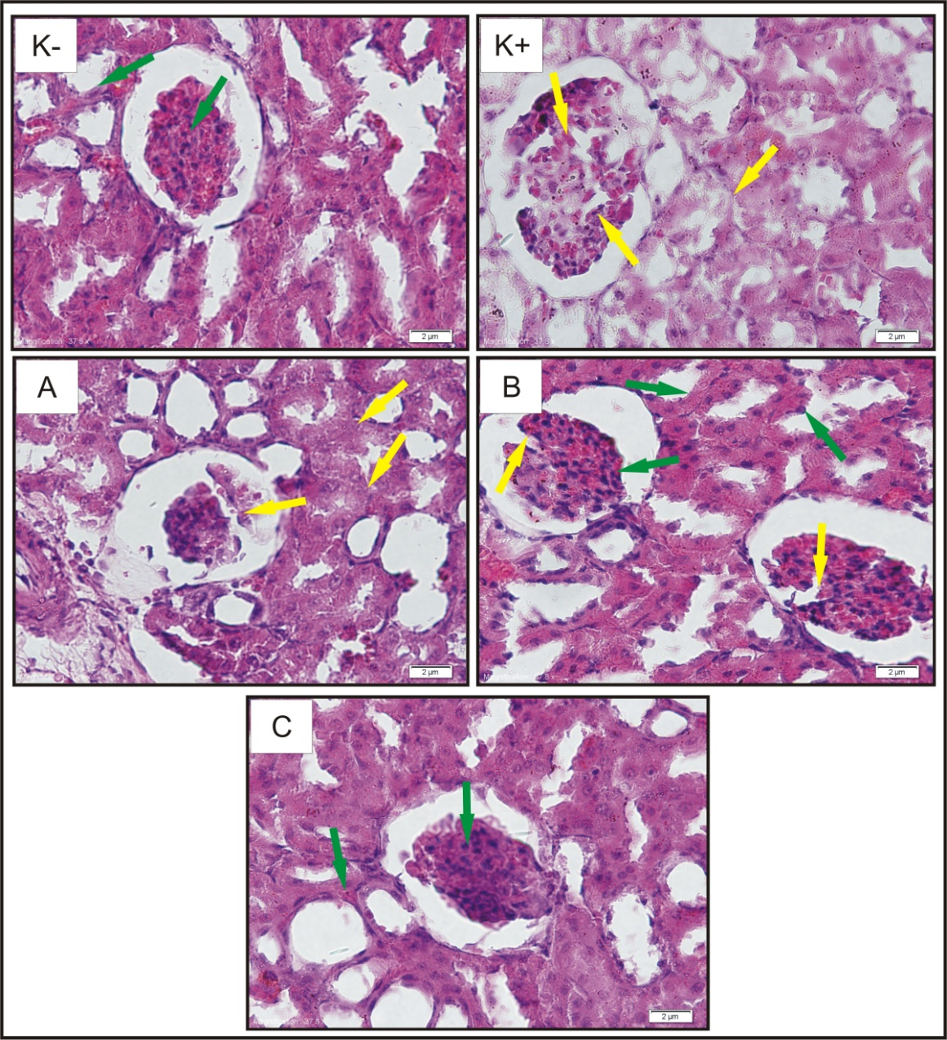

**Figure 2**. Histology of the rat kidney magnified 600 times

Control mice (K-), diabetic mice (K+), therapeutic mice which is treated with doses of D-alpha-tocopherol 100 mg/kg BW (A), 200 mg/kg BW (B), and 300 mg/kg BW (C). Glomerolus damage and cell boundaries are not clear ( ), Glomerolus looks intact and boundary between the cells are clearly visible ( ).

**Table**

**Table 1.** MDA Level Profile in Control Mice, Diabetic Mice, and Therapeutic Mice Kidney

|  |  |  |
| --- | --- | --- |
| Mice Groups | MDA Level (μg/mL) | Difference in MDA levels to Healthy Controls (%) |
| Controls (non-diabetic) | 0,438 ± 0,022 | 0,00 |
| Diabetic | 2,242 ± 0,152 | 412,07 |
| Therapy 100 mg/kg BB | 0,636 ± 0,092 | 45,26 |
| Therapy 200 mg/kg BB | 0,549 ± 0,051 | 25,43 |
| Therapy 300 mg/kg BB | 0,509 ± 0,052 | 16,38 |