Effect Of Methyl Mercury towards Number of Microglia Cells and Expression of iNOS On The Brain in Rats (Rattus norvegicus)

Yuli Kusuma Dewi*, Aulanni'am and Chanif Mahdi

Department of Chemistry, Faculty of Sciences, Brawijaya University, Jl. Veteran Malang 65145, East Java, Indonesia; *Corresponding author: yulikusumadewi77@gmail.com; Phone: +62341575838

Received day moth year; Accepted day moth year (will be given)

ABSTRACT

Methyl mercury (MeHg) has the highest toxicity among the derivative of the organic mercury compounds. Rate of accumulation of MeHg in the body is very high because it is soluble in lipids. The ability of methyl mercury binds to proteins in the body causing MeHg to penetrate the blood-brain barrier easily, so that it can quickly disrupt the central nervous system and speed up nerve cell damage. This paper reported the effect of methyl mercury on the number of microglia cells and expression of iNOS in the brains of Rattus norvegicus. In this study, rats were divided into two groups: a control group with no exposure of MeHg and groups of rats exposed with MeHg at a dose of 0.6 mg/kg BW/day given orally for 21 days. Number of microglia cells is investigated using silver nitrate staining method and iNOS expression is determined by immunohistochemistry methods. The results showed that exposure with MeHg in a dose of 0.6 mg/kgBW can increase the number of microglia cells and iNOS expression respectively as mush as 151.63% and 918.08% .

Keyword: Methyl mercury, microglia, brain, iNOS, immunohistochemistry

INTRODUCTION
The use of metallic mercury has been so widely grown in many areas of life such as health, agriculture, and industry. Mercury has been widely used as a wound cleanser, vaccines, syphilis treatment, cosmetic ingredients, herbicides, pesticides, paint, lamps, dental amalgam, and other uses in the chemical industry and pharmacy^{[1]}. The high use of mercury followed by increased waste generated from industry until most of the waste discharged into water bodies.
Mercury in water through the food chain may change into methyl mercury (MeHg) which is generated through the process of methylation by microbes in the water, and then eaten by fish and other aquatic biota thus easily get into the human body to consume. Based on the decision of the Minister of Health Republic of Indonesia (Kepmenkes No.907/Menkes/SK/VII/2002), the maximum tolerable limit of mercury in water is 0.001 ppm. Indian Commerce Minister set a threshold limit for mercury concentration in fish is 0.5 ppm and 1 ppm for other foods, while the concentration of MeHg exposure was 0.25 ppm on food^{[2]}.
Methyl mercury is a pollutant that is neurotoxic to the central nervous system (can cause abnormal neuronal even cell death). MeHg exposure to low doses has been shown to cause neurological disorders in humans. Epidemiological studies indicate that MeHg levels inversely related to pediatric neurologic scores in populations with high fish consumption figures^{[3]}. MeHg can also cause damage to DNA, lipid peroxidation, inactivation of proteins and other effects. Other effects caused by heavy metals when contaminated in a relatively high number of MeHg is the production of Reactive Oxygen Species (ROS) and can affect the innate immune response^{[4]}.
The ability of methyl mercury are soluble in fat and has a high affinity for thiol groups caused it easily penetrates the blood brain barrier and interfere the central nervous system. The damage to brain neuronal cells can cause inflammation of the brain cells. The inflammatory response that occurs is the activation of microglia cells, infiltration of neutrophils and macrophages in the brain parenchyma leading to increased production of cytokines, which is TNF-α. Activation of TNF-α also led to the activation of iNOS (inducible Nitric Oxide Synthase) to produce radical NO. Therefore, in this study, the effects of MeHg exposure on the number of microglia cells and expression of iNOS in rat brain are studied in details.

EXPERIMENT
Animals and Experimental Design
White rats (Rattus norvegicus, male, 2-3 months old, body weight 100-200 g) were placed in a room temperature in the animal house of Cellular and Molecular Biology Laboratory, Mathematics and Sciences Faculty, Brawijaya University Malang and adapted for 1 week with rats given a pellet feed and drinking water. Furthermore rats were divided into 2 groups: 1 group of healthy controls without giving MeHg and 1 group exposed with meHg at a dose of 0.6 mg/kg BW/day.
Negative control group of rats (healthy) were given normal rat pellet and drinking water (distilled water) everyday for 21 days. After 21 days, the rats were sacrificed and dissected to take his brain. Groups of rats exposed with MeHg at a dose of 0.6 mg/kg BW/day was given orally for 21 days. MeHg given in the form of methyl mercury chloride (purchased from of Arema.Sigma-Aldrich, St. Louis, USA) which was dissolved in approriate volume of distilled water. After 21 days of treatment, rats were sacrificed by dislocation of cervicalis and then brain organ was harvested. The organ was soaked in a solution of paraformaldehyde (PFA) 4% for the manufacture of tissue slide. All conditions and handling animals were conducted with protocols approved by Ethical Clearences Committe of Brawijaya University (No.156-KEP-UB).

Microglia Observations by Silver Nitrate
Staining microglia with silver nitrate is performed through deparafination by tissue slide put in xylol solution twice for each 10 minutes, followed by absolute ethanol (96%) twice, each 5 minutes, 90% ethanol and 70% for each 1 minute, respectively. Slides were rinsed in distilled water for 5 minutes, then incubated in oxidizing solution for 20 minutes and rinse again with distilled water.
Silver nitrate solution (0.2%, 20 mL) was preheated in the waterbath at 70°C. Meanwhile, the slides were incubated in a solution of Zinc formalin for 5 minutes, and rinse with distilled water. Then the slides were incubated in a preheated solution of silver nitrate for 5 minutes at a temperature of 70°C (note: Discard solution after this stage), and rinse slides with distilled water. Afterwards, dehydrated the slide twice with absolute ethanol.
Preparation of reducing solution is conducted as the following procedures; mixed 25 ml of 1% hydroquinone and 15 mL solution of gum mastic 2.5%, then filtered using filter paper. Added 6 drops of silver nitrate solution (1%) and heated above all reducing solution at a temperature of 70°C. Then, Incubated slides in a solution of gum mastic for 3 minutes and then dried slide for 1 minute or until the mastic gum perfectly dry. Afterwards, incubated slides on reducing solution that has been heated for 10-15 minutes at a temperature of 70°C or until brown color is formed. Discard solution when this stage has been completed and then rinse the slides in distilled water. Later, dehydrated the slide quickly three times in absolute alcohol and mounting is done with Entellan.
Expression of iNOS by Immunohistochemistry Methods
Expression of iNOS by immunohistochemistry methods is performed through deparafination of tissue slide in two change of xylol, storey ethanol (98%, 95%, 90%, 80%, 70%), and distilled water for each 5 minute, respectively. Tissue slide were washed with PBS pH 7.4 for 5 minutes. Then, slide were incubated in 3% H₂O₂ for 20 minute and washed with PBS pH 7.4 for 5 minute three times. Blocking the tissue slide with 1% BSA in PBS pH 7.4 for one hour. The slide were washed with PBS pH 7.4 for 5 minute three times. Then slide were incubated with primary antibody for iNOS rat overnight at 4°C, then washed with PBS pH 7.4 for 5 minutes three times. After that, Incubated slide using secondary antibody anti-rabbit biotin for 1 hour at room temperature. Washed with PBS pH 7.4 for 5 minutes three times and sprinkled with SA-HRP (Strepta Avidin- Horseradish Peroxidase) and incubated for 40 minute. Washed with PBS pH 7.4 for 5 minutes three times and sprinkled with DAB (diaminobenzidine) and incubated for 10 minutes, then washed with PBS pH 7.4 for 5 minutes three times. Counterstaining the slide with Hemotoxylen Mayer for 10 minutes. Slide were washed with flowing water and then rinsed with distilled water and dried it. Mounting slide with entellan and covered with glass cover. Slide express iNOS if there are brown colour or dark brown on the tissue.

RESULT AND DISCUSSION

Effect of Methyl mercury Against Microglia Activation in the Brain

Microglia are brain macrophages and contained in a defense system in brain cells. In addition to the brain macrophages, microglia are the main producers of cytokines in the brain. Any injury to the brain or damage to the nervous system bringing in microglia to produce inflammatory mediators such as proinflammatory cytokines (interleukin and TNF-α) and ROS which in turn will activate other glial cells, so that cytokines and chemokines are released from the microglia^{[5]}. In addition, activated microglia also will enhance the regulation of iNOS and improve peroksinitrit formation^{[6]}.
To examined the number of microglia cell in rat brain tissue, tissue staining technique of silver nitrate was used. Silver nitrate that was applied to the slide will be reduced to metallic silver which will be presipitated on the surface of nerve tissue, including glial cells. Colors that will arise in cells after the staining is usually a dark brown to brown^{[7]}. Microglia can be distinguished from the others because it forms an elongated core with a dispersed grain chromatin.
The results showed that administration of MeHg in a dose of 0.6 mg/kg BW/day increased the number of microglia cells in the brain (shown in Table 1). The number of microglia cells in the brain tissue of rats exposed with MeHg has increased as much as 151.63% compared to the control rats. The average number of microglia cells for control group rats was 7, 933 ± 6.24 cell whereas rats with MeHg exposure dose of 0.6 mg/kg BW/day was 21.6 ± 13.46 cell.
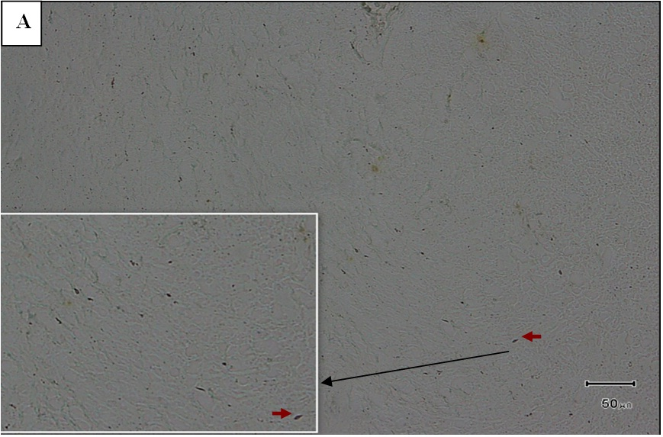

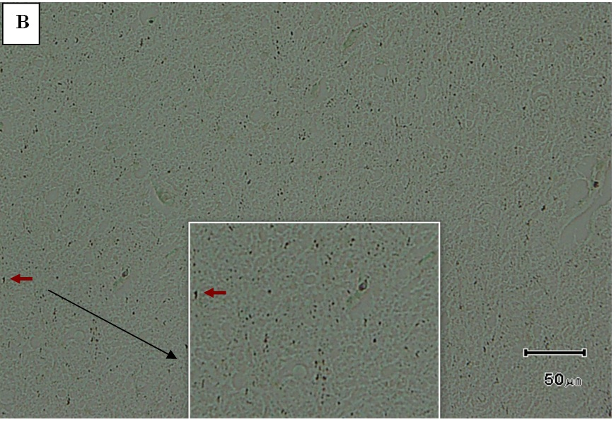

Figure 1. Silver nitrate staining results for microglia cells with 400 times magnification. A (tissue of rat brain without MeHg or control group), B (tissue of rat brain that exposed with MeHg dose 0.6 mg/kg BW), → ( microglia cells), → (magnification).
Table 1. Profile number of microglia cells from control group rats and group exposed with MeHg at a dose of 0.6 mg / kg / day
Treatment Group | Total Average of Microglia Cell | Difference in Total Microglia Cell to Healthy Controls (%)
Control | 8.60 ± 1,41 | 0.00
MeHg 0,6 mg/Kg BW | 21.64 ± 2.32 | 151.63

Statistical analysis showed that there are significant differences between the number of microglia cells in control group rats with rats given a dose of MeHg exposure to 0.6 mg/kg BW/day (p <0,01). This is shows that MeHg exposure with a dose of 0.6 mg/kg BW/day could increased the number of microglia cells in the rat brain. This result agree well with Setyopranoto (2012)^{[8]} experiment that said any injury to the nerves can activated glial cells in the nucleus to produce pro-inflammatory mediators such as cytokines and ROS. Activation of microglia increase the production of other cytokines and chemokines in the brain.
The number of microglia in the brains of rats groups that exposed to MeHg was higher than control group, as the result from the immune response of the body when against toxins from outside (MeHg). The ability of MeHg was easily penetrates the blood brain barrier, allowing MeHg to interact with neurons and cause neuronal cell damage. This is cellular damage signal that activates macrophages/microglia, thus more numerous than in control rats. Presence of microglia activation were seen in the control group because under normal circumstances, the body activates microglia/macrophages to eat the debris-debris in order to maintain homeostasis of the body's tissues. However, the activated macrophages in relatively small amounts.

Expression of iNOS in White Rat BrainTissue (Rattus norvegicus) Exposed with Methyl mercury
NO or nitric oxide has an important role in the pathogenesis of systemic. The existence of certain toxins from the outside increase the release of proinflammatory cytokines, which greatly influence the increase in NOS activity and NO release. In this case, the production of proinflammatory cytokines, especially TNF-α and IL-β increase the production of NO in large numbers, through increased activation of iNOS. This excessive production of NO and caused endothelial and tissue damage^{[9]}.
To confirm the expression of iNOS in rat brain tissue, immunohistochemical techniques was used in this study. Immunohistochemistry is a technique for the detection of proteins based on antigen-antibody reaction. This technique uses two antibodies (primary antibodies and secondary antibodies that was conjugated with a specific enzyme such as peroxidase). Antigen will be bound to the primary antibody molecules which would react with the secondary antibodies that was conjugated with peroxidase. The presence of peroxidase serves to catalyze the reaction between the chromogen DAB and H₂O₂, thus forming a brown precipitate that indicates the presence of the desired molecule. Chromogen is a used compound to apply color to the cells that produce specific antibodies^{[10]}.
The results showed that the average number of cells that express iNOS in the brains of rats exposed with MeHg dose of 0.6 mg/kg more than the control group rats with the number of excalation of iNOS expression to the control rats was 918.08% (Table 2). Statistical analysis showed that there are significant differences between the number of cells that express iNOS in control group rats with rats that were given exposure with a MeHg dose of 0.6 mg/kg BW/day (p<0,01).

Table 1. Profile of the number of cells that express iNOS from control rats and rats exposed to MeHg dose 0.6 mg/kgBW/day
Treatment Group | Total Average of Cell that Express iNOS | Difference in Expression of iNOS to Healthy Controls (%)
Control | 0,167± 0,05 | 0.00
MeHg 0,6 mg/Kg BW | 1,700 ± 0,13 | 918.08
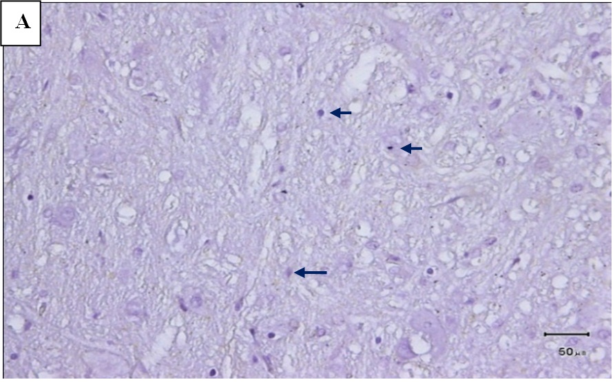

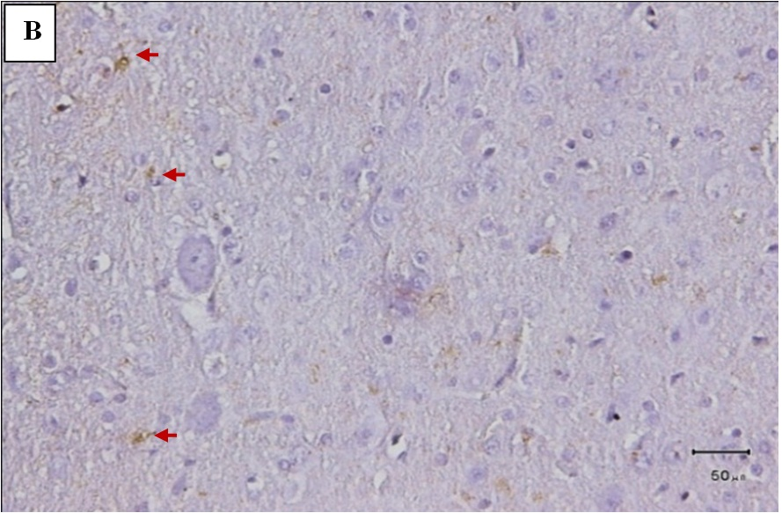

Figure 2. Immunohistochemical result for expression of iNOS in brain tissue with a magnification of 400x, A (tissue of rat brain without MeHg), B (tissue of rat brain that exposed with MeHg dose 0.6 mg/kg BW, → ( cells that express iNOS), → (normal cell)
The presence of iNOS expression contained in the control rats, although in small amounts, because in under normal circumstances the production of NO still produced by iNOS, but in a tolerable amount of body, cause NO radicals associated with a molecule that plays a role in maintaining the balance of body^{[11]}. The high expression of iNOS in brain tissue indicated that NO was over produced in the cell, so that it can be seen that the cells/tissues were in pathological conditions. The presence of NO radicals in the cell in excess will cause cell damage occurs more rapidly due to the ability of NO to react with ROS such as superoxide to form peroxynitrite that will react with hydroxyl radicals. Furthermore, Superoxide and Hydroxyl radicals can react with PUFA (Poly Unsaturated Fatty Acids) and cause lipid peroxidation chain reaction that accelerates membrane damage in the brain tissue.

CONCLUSION
Methyl mercury exposure with a dose of 0.6 mg/kg BW/day increased the number of microglia cells with an increased number of microglia cells was 151.63% and iNOS expression in rat brain tissue was 918.08% compared to control group.

ACKNOWLEDGMENT (if any)
This study is part of the research about Neurotoxic Effect of Mercury. The authors would like to thank to Dr. Paulus Sugianto for the chance to be the member of this research. The authors also thank to Dr. Sasangka Prasetyawan, MS and Masruri, Ph.D for the discussion, and Dr. Sc Akhmad Sabarudin who helped the forming of this manuscript.
REFERENCES
[1]. Chamid C., N. Yulianita dan P. Renosari, Kajian Tingkat Konsentrasi Merkuri (Hg) Pada Rambut Masyarakat Kota Bandung, Prosiding SNaPP2010 Edisi Eksakta, ISSN : 2089-3582, 107-131, 2010.
[2]. Bhattacharyya, S., S. Chatterjee and S. Basu, Mercury Pollution : The Problem Still Persists. Everyman’s Science Vol. XLII No. 5, 279-286, 2008.
[3]. Davidson, P.W., G.J Myers, C. Shamlaye, C. Cox, and G.E. Wilding, Neurotoxicol Teratol, 2004, 26(4), 553-9.
[4]. Dominggus, R, Jurnal Saintis Vol.1 No.1, 10-34, 2012.
[5]. Benakis, C., L.A. Vaslin, C. Pasquali and L. Hirt, J Neuroinflamm. 2012, 76(9); 1-8.
[6]. Blaylock, R.L, J Altern Ther Health M, 2009, 15(1), 46-53.
[7]. Hernawati. 2008. Jaringan Ikat, http://file.upi.edu/Direktori/FPMIPA/JUR._PEND._BIOLOGI/197003311997022-HERNAWATI/FILE_22.pdf. 13 Oktober 2012.
[8]. Setyopranoto, I. Pengaruh Penurunan Kadar Vascular Endothelial Growth Factor-A (VEGF-A) Terhadap Kejadian Odem Otak Pada Pasien Stroke Iskemik Akut, Fakultas Kedokteran dan Kesehatan, Universitas Gajah Mada, Disertasi, 2012.
[9]. Prasetyo, S. dan H. Witjaksono, The Effect Of Intravenous Ketamine on Macrophage Nitric Oxide Level In Balb/C Mice With Lipopolysaccharide Induced, Medica Hospitalia, Vol 1(1), 12-15, 2012.
[10]. Laila, S.R, Immunohistochemical Profiles of Antioxidant Superoxide Dismutase (SOD) in Small Intestine of Probiotic and Enteropathogenic E. coli (EPEC)-treated Rats, Faculty of Veterinary, Institut Pertanian Bogor, Thesis (In Indonesia), 2011.
[11]. Darmawan, R., Astaxanthin Prevents The Nerosis And Inflamation Process Of The Muscle Tissue That Is Caused By Overtraining In Rats, Universitas Udayana Thesis (In Indonesia), 2012.

ATTACHMENTS : Ethical Clearance Certificate

