“Maaf pak saya blm bisa mengubah dari titik ke koma, tapi saya melampirkan data yg bisa d edit d word”

Effect of optimum contact time GASP on Cr(VI) adsorption

Figure 2. The relation of adsorption contact time to Cr(VI) ion mass which absorbed per gram of GASP adsorbent (x/m).

Effect of Cr(VI) concentration on adsorption capacity in GASP

Figure 3. The relation of Cr(VI) concentration to Cr(VI) ion mass which absorbed per gram of GASP adsorbent (x/m)

Figure 4. Langmuir equations on GASP from Cr(VI) concentration after adsorption process (C) to concentration per Cr(VI) ion mass were absorbed per gram of adsorbent (Cm/x).

Figure 5. Langmuir equations on active zeolite from Cr(VI) concentration after adsorption process (C) to concentration per Cr(VI) ion mass were absorbed per gram of adsorbent (Cm/x).

Figure 6. Langmuir equations on active zeolite granules from Cr(VI) concentration after adsorption process (C) to concentration per Cr(VI) ion mass were absorbed per gram of adsorbent (Cm/x).

Figure 7. Langmuir equations on ASP from Cr(VI) concentration after adsorption process (C) to concentration per Cr(VI) ion mass were absorbed per gram of adsorbent (Cm/x).

Figure 8. Maximum adsorption capacity on different adsorbents

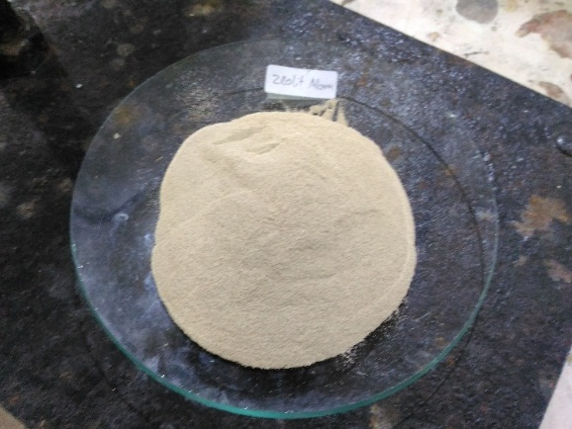
Zeolit alam dari Kota Blitar dengan warna lebih coklat kekuningan dibanding zeolit alam lain karena kadar besi yang tinggi ( berdasarkan data XRF)

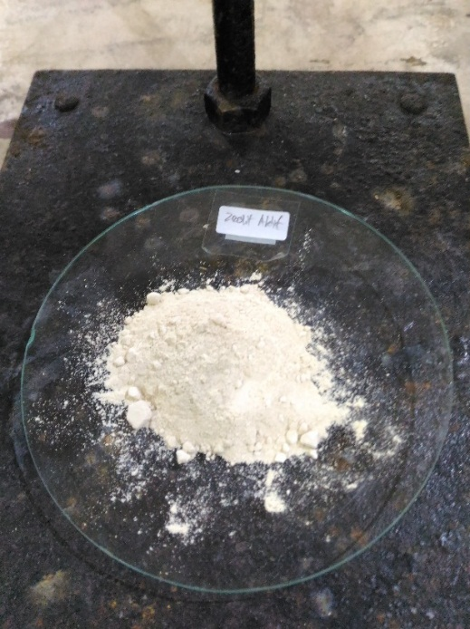
Zeolit yang telah diaktivasi dengan menggunakan HCL dan pemanasan 105ᴼC

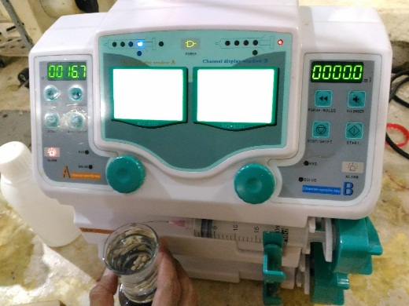
Penggunaan syringe pump dalam pembuatan granul

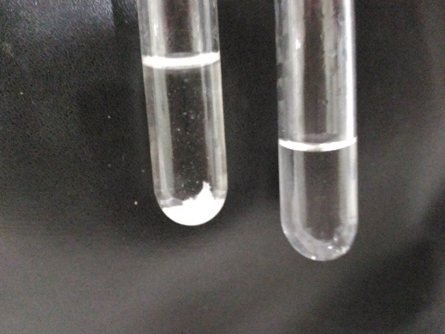
Uji kualitatif bebas ion fosfat dengan Mg(NO₃)₂ terbentuk endapan putih Mg₃(PO₄)₂, filtrat yang masih ada ion fosfat (kiri) dan bebas ion fosfat (kanan)
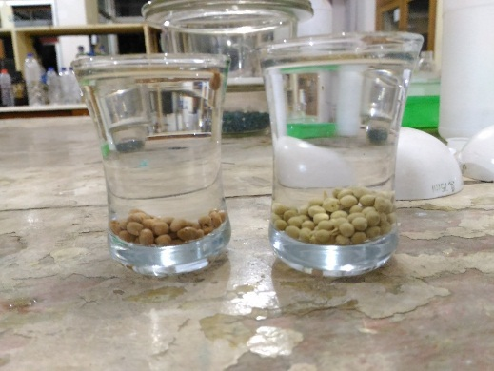
Kiri GASF dan kanan granul zeolit aktif sebelum dikeringkan

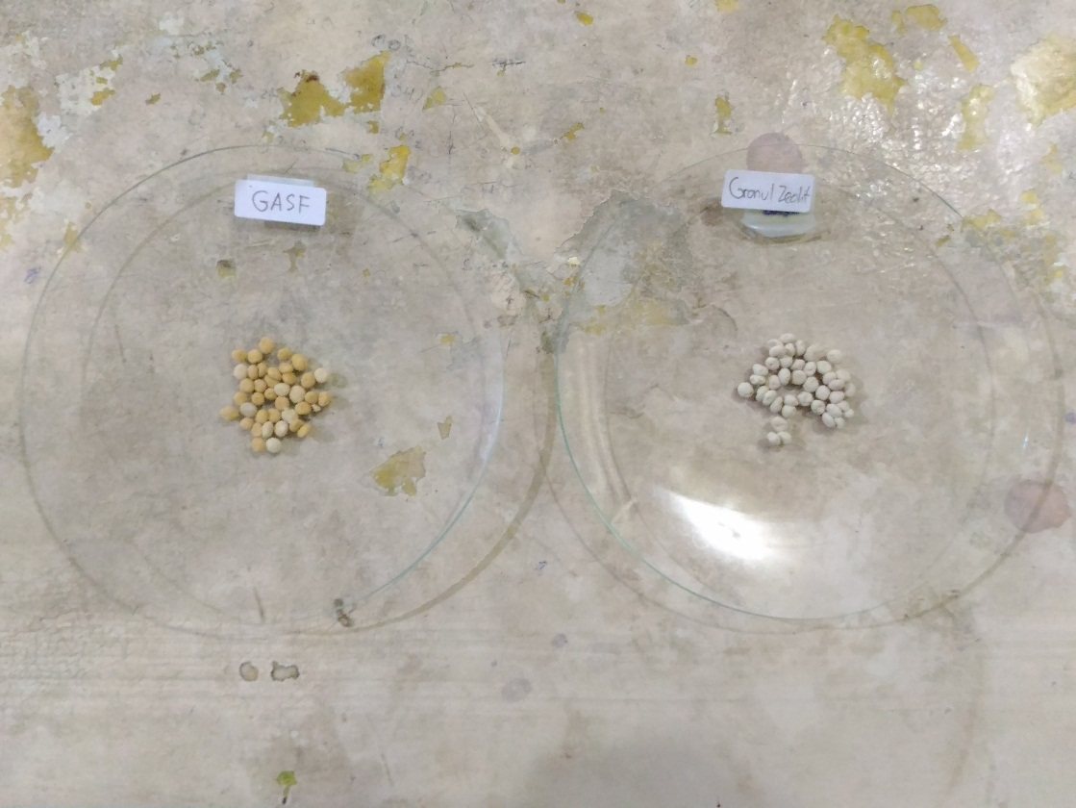
Kiri GASF dan kanan granul zeolit aktif setelah dikeringkan

