**Figures and table**

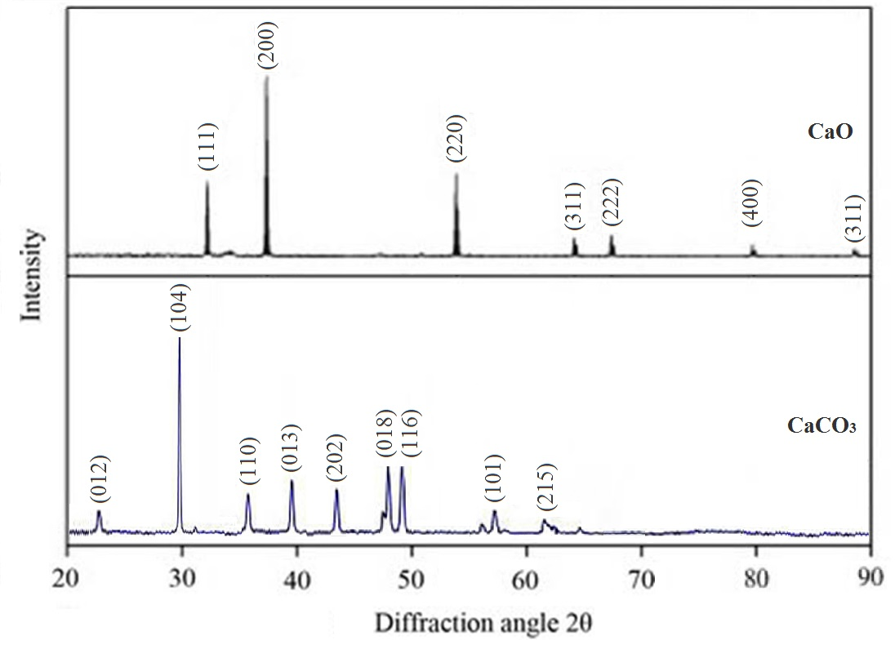

Figure 1. The XRD powder patterns of calcium oxide and calcium carbonate from JCPDS

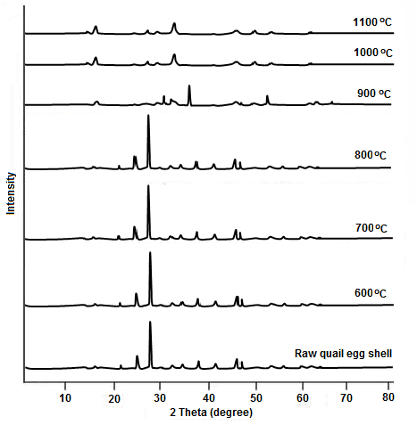

Figure 2. The XRD powder patterns of decomposed quail egg shell at various temperatures.

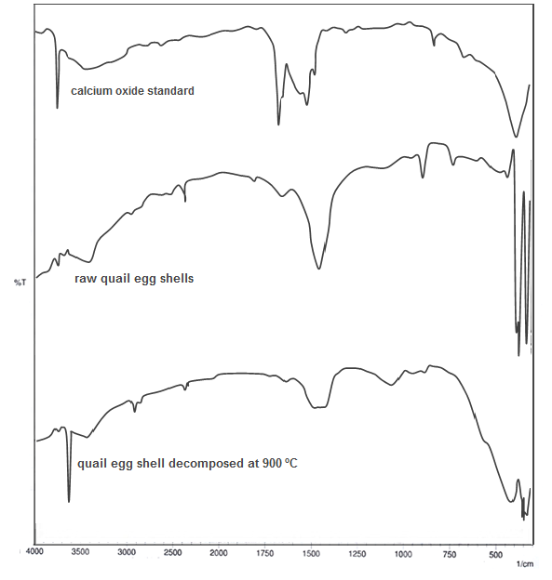

Figure 3. The FTIR spectrum of calcium oxide standard, quail egg shell, and quail egg shell decomposed at 900 oC.

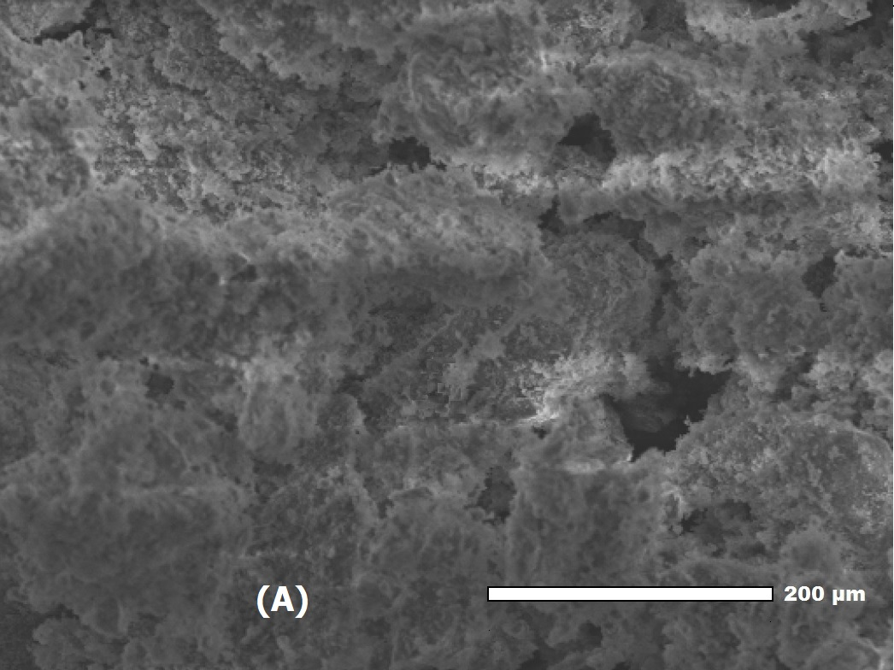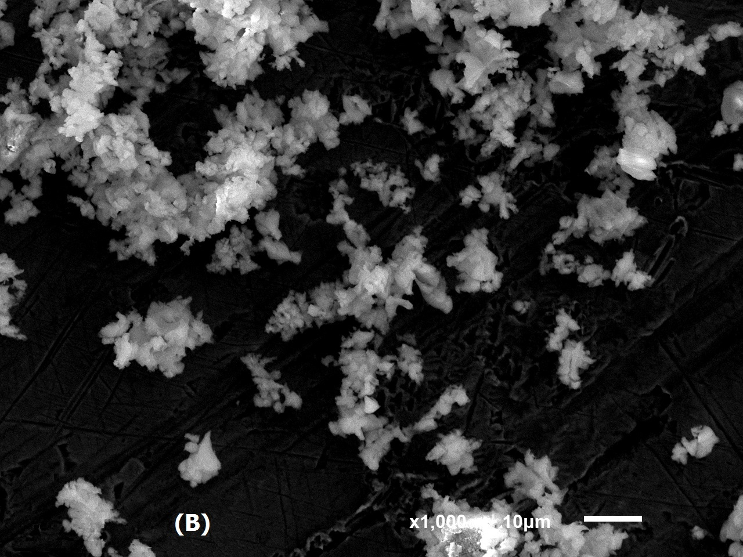

Figure 4. The SEM Photo of quail egg shell (A) and CaO from quail egg shell decomposed at 900 oC (B).



Relative Pressure [*P*/*P*0]

Adsorbed volume [cm3/g



Figure 5. The N2 sorption desorption of CaO from quail egg shell decomposed at 900 oC

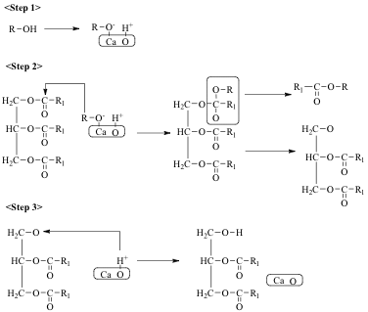

Figure 6. Transestrification reaction mecanism of triglyceride with methanol by calcium oxide as heterogeneous catalyst (Ali *et.al*, 2015).

Table 1. Textural properties of CaO from quail egg shell decomposed at 900 oC.

|  |  |  |  |
| --- | --- | --- | --- |
| CaO | Surface area (*S*BET, m2/g) | Pore volume (VBJH, cm3/g) | Pore diameter (∅BJH, nm) |
| Value | 68 | 1.65 | 6.6 |

Table 2. The physochemical properties of waste frying palm oil

|  |  |
| --- | --- |
| Properties | Value |
| Density  (g/cm3) | 0.90 |
| Viscosity  (mm2/s) | 56.68 |
| Free fatty acid (mg/KOH) | 2.80 |
| Iodine number  (g I2/100 g) | 124.36 |

Table 3. The properties of biodiesel from waste frying palm oil.

|  |  |  |
| --- | --- | --- |
| Properties | Biodiesel | Biodiesel standard (SNI 04-7182-2006) |
| Density  (g/cm3) | 0.86 | 0.85-0.89 |
| Viscosity  (mm2/s) | 5.50 | 2.30-6.00 |
| Free fatty acid (mg/KOH) | 0.56 | Max 0.80 |
| Iodine number  (g I2/100 g) | 60.49 | Max 115 |